1ST QUESTION-BOOK BANK MANAGEMENT SYSTEM

USE-CASE DIAGRAM:

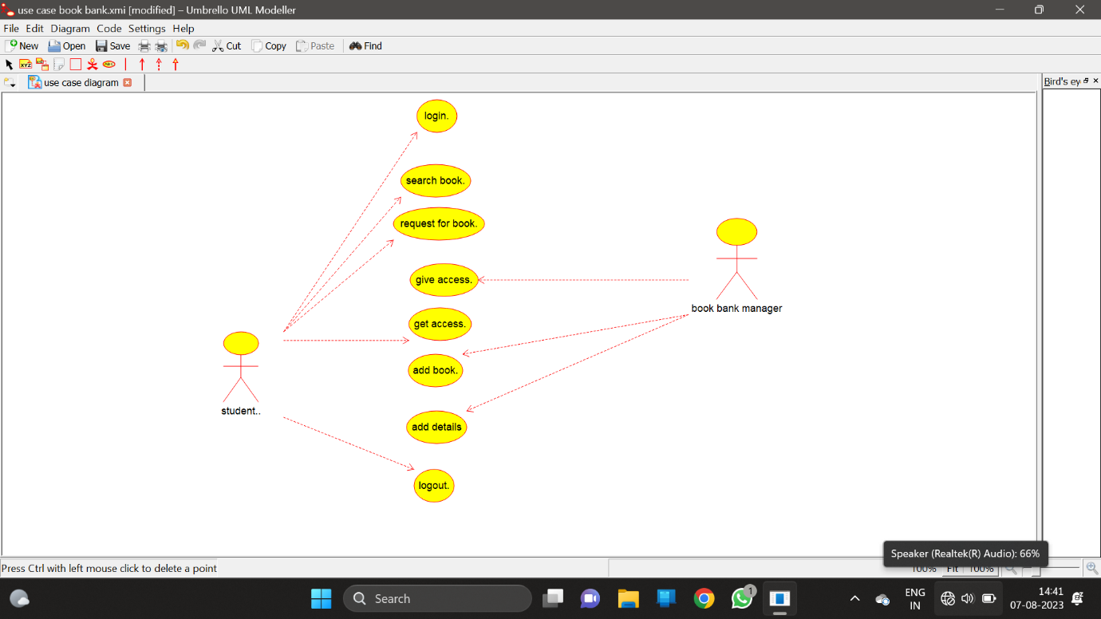

ENTITY RELATIONSHIP DIAGRAM:

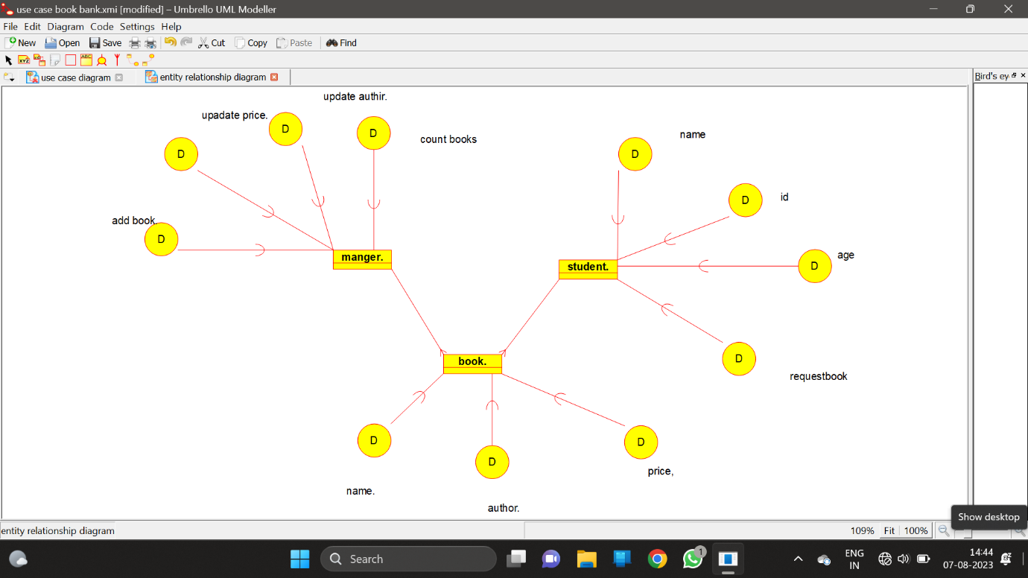

CLASS DIAGRAM:

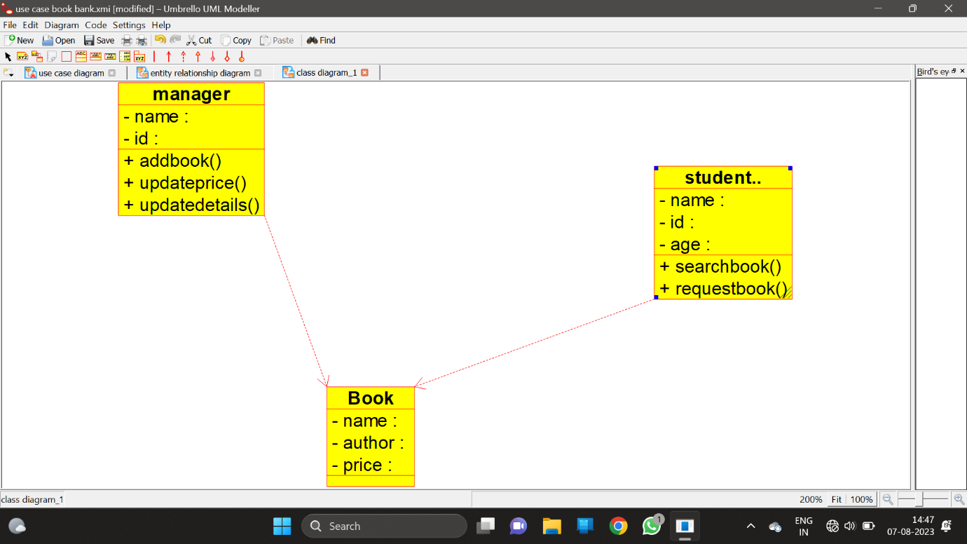

2ND QUESTION – PASSPORT MANAGEMENT SYSTEM

ACTIVITY DIAGRAM:

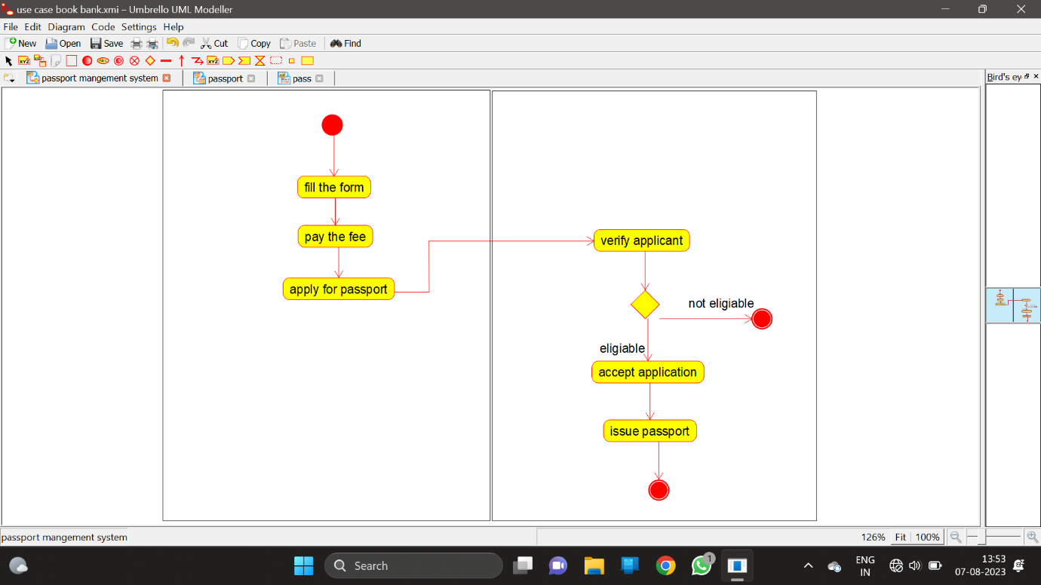

DEPLOYMENT DIAGRAM:

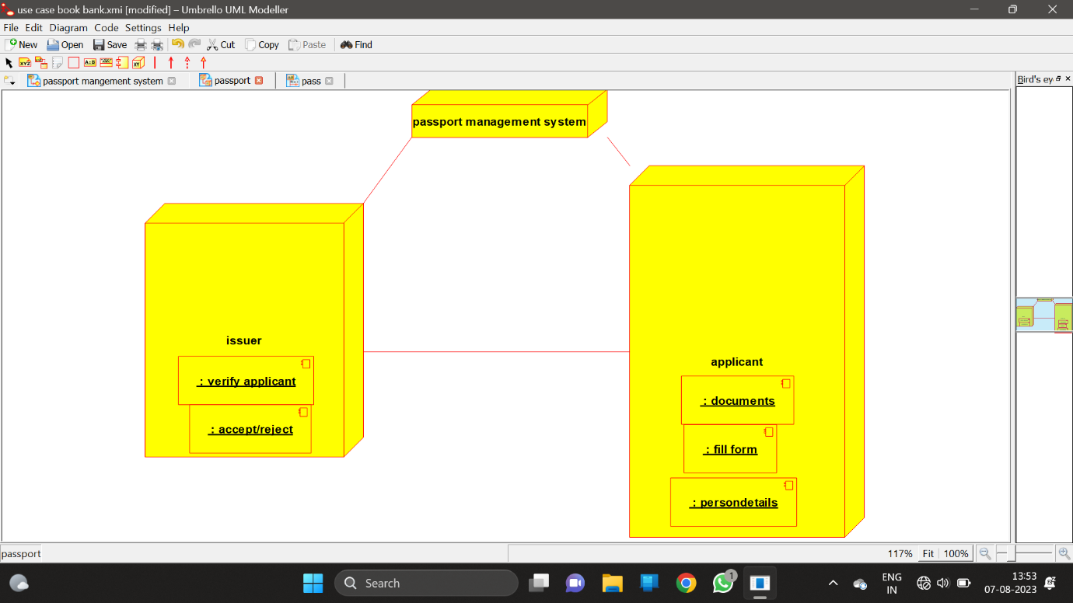

SEQUENTIAL DIAGRAM:

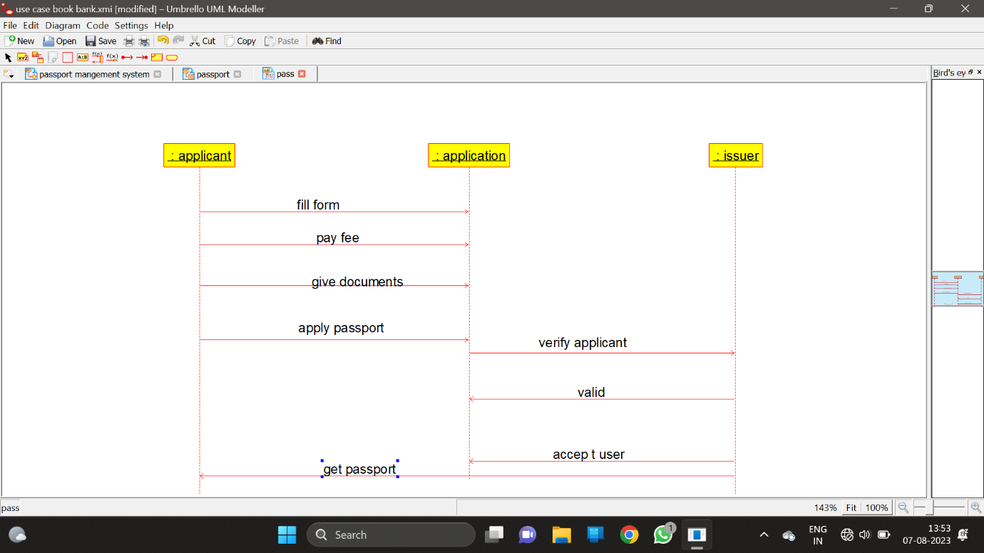

3RD QUESTION-COURSE RESERVATION SYSTEM:

COLLABRATION DIAGRAM:

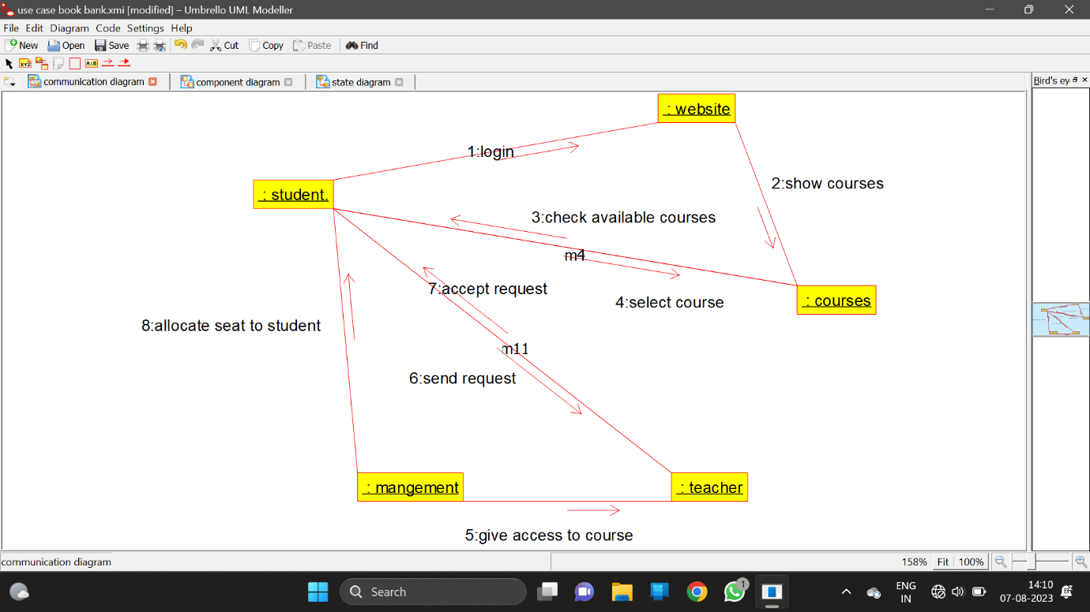

COMPONENT DIAGRAM:

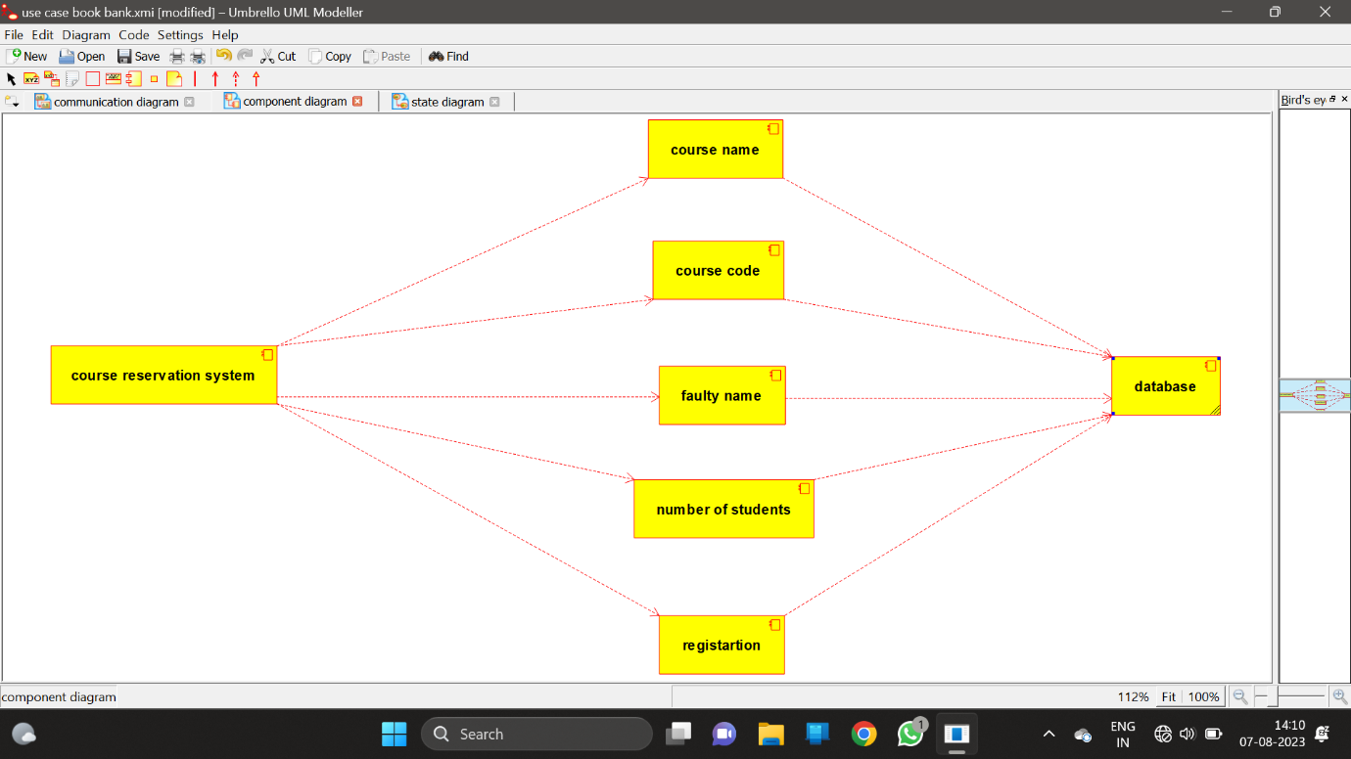

STATECHAR DIAGRAM:

